**Custom Types and Elements**

You can create and use custom elements for the Drivers Gantt.

A custom element can be created / added anywhere on the Drivers Gantt where a mouse-over open the little blue + sign.

They occur at the beginning or end of a trip. Clicking one of them opens its inform- ation box:

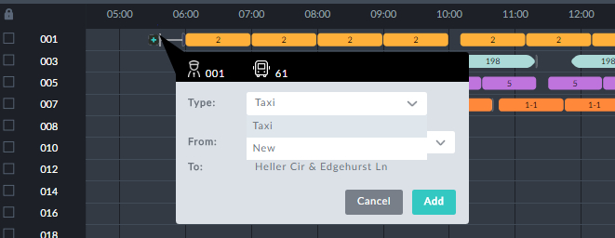

They also occur in any un-assigned gap between trips. Again we show an example with its information box open:

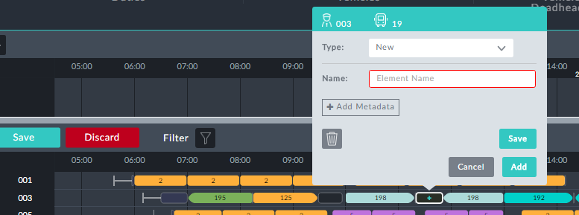

*Figure 1-1: Creating a custom element in an un-assigned gap*

By way of illustration, we will use the second example to create several new element types, "Refuel" and "Standby". We then use the both element types to create refueling and standby breaks.

Ø **To create and use several new elements:**

1. Mouse-over a gap between two trips and click as in **Figure 1-1**. The information box opens as shown.



If there are already custom types in the schedule, you may see one of them

instead of *New* in the **Type** field. Click it to open a drop list of available types. *New* will appear at the bottom of the list. Select *New* and continue to the next step.

**Adding Metadata** is for use in conjunction with Optibus Professional Ser-

vices.

2. In the **Name** field, enter the name of the new element and click **Save**. The new

type is saved and an information box is opened:

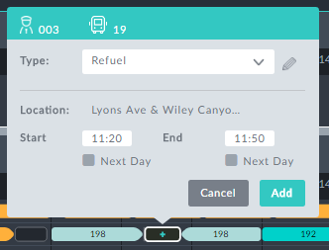

3. You can modify the times here - you do not have to assign the whole gap. Set the

**End** field to 11: 35

4. Click **Add**. Here is the result, with the information box opened:

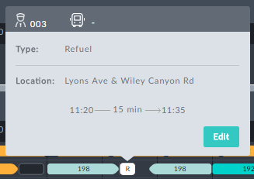

5. Mouse-over the remaining part of the gap and click it. The following dialog opens:

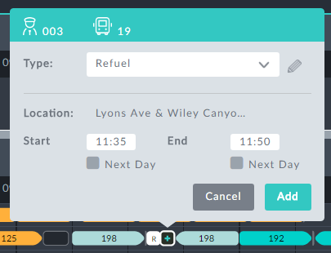

We will turn this into a new Standby type.

6. Open the **Type** drop down list and choose New. The new type dialog opens:

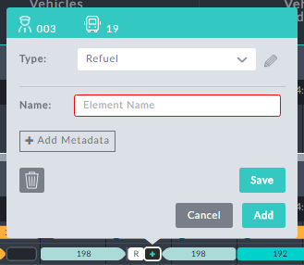

7. Click **Type**:

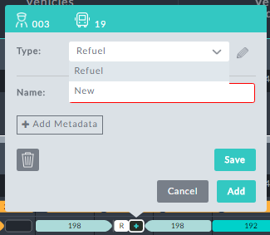

8. Choose **New**.

9. In the **Name** field, enter "Standby":

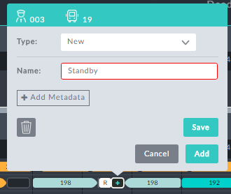

10. Click **Save**.

**Save** saves the new type. **Add** saves the type and adds a new element of the

new type to the Drivers Gantt.

11. If you see this,

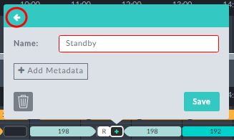

click the circled arrow.

You can use this box to rename the type to something else, for example,

"Standby (special)". Clicking **Save** commits the change for this case and takes you to the next step.

An editable information box for the remaining part of the gap is displayed:

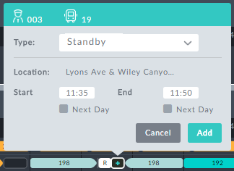

12. Click **Add**. Here is the outcome (with the information box opened):

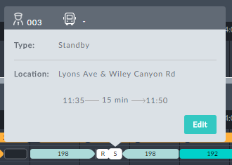

At any point the two new elements, "Refuel" and "Standby" are available. Mouseing-over

any other gap and opening its information box shows something similar to this:

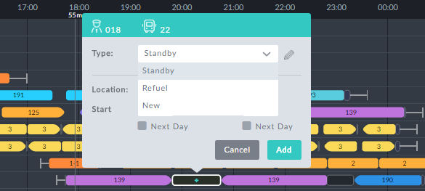

Proceed as above to add custom elements to the gap.